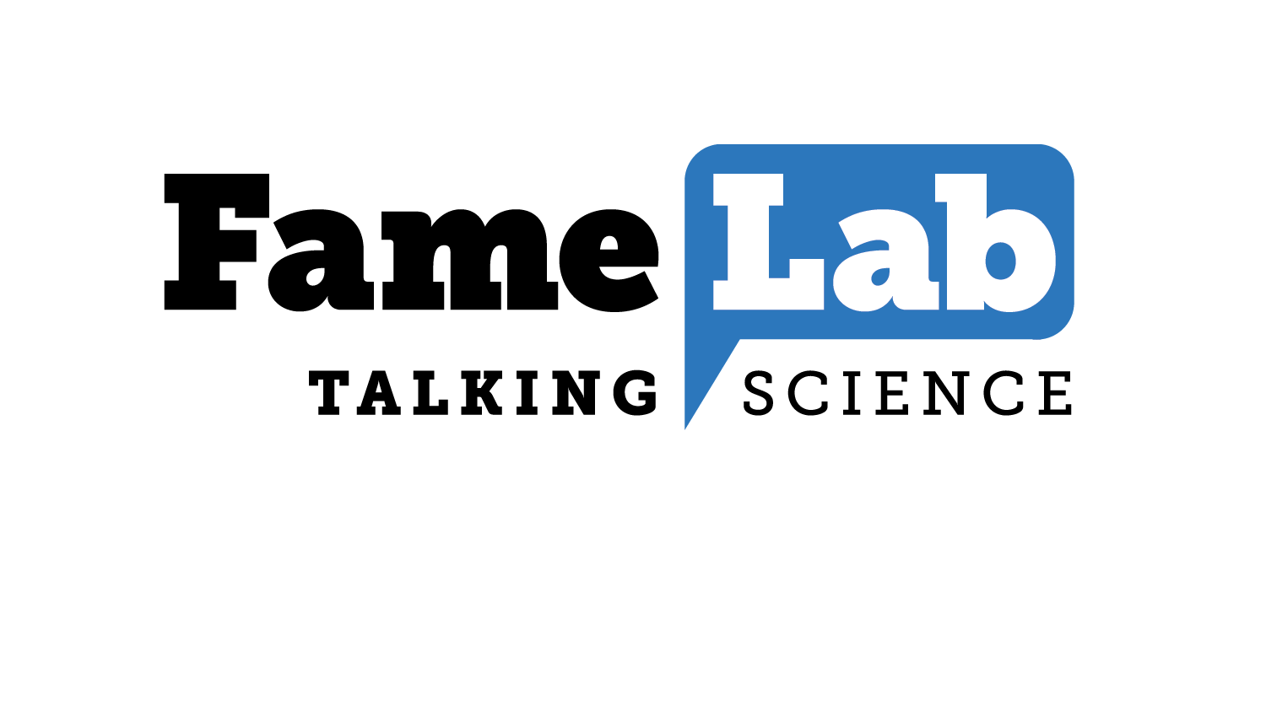

**The British Council wants you: Apply now for a chance to win at the UK Famelab finals**

**For release: Monday 9 Jan** **2017**

Applications for FameLab 2017 are now open! The British Council is looking for enthusiastic early-career researchers with a passion for public engagement to present their science at FameLab Australia.

One winner will go on to represent Australia in the international FameLab finals at the Times Cheltenham Science Festival, UK, in **June 2017.**

FameLab is the world’s leading science communication competition. It aims to find and mentor young science, technology, engineering and mathematics (STEM) researchers who want to share their stories with the world.

Applicants are invited to submit a short video entry and, if shortlisted, will be invited to perform live at one of the national semi-final events taking place in NSW, QLD, VIC and WA between March and April this year. The national final – hosted by astrophysicist and media personality, Dr Alan Duffy – will take place at the Western Australian Maritime Museum on Thursday 4 May.

Contestants have just three minutes to convey their scientific concept on stage in an original, entertaining way and are judged on the content, clarity and charisma of their presentations.

Erinn Fagan-Jeffries from The University of Adelaide was declared winner of FameLab Australia 2016 for her brilliant horror-film tale about the caterpillar-killing parasitoid wasps that are saving our potato crops.

She went on to represent Australia at the international FameLab competition at the Times Cheltenham Science Festival, where she competed against scientists from more than 25 countries.

Erinn says, “FameLab was an amazing experience. The competition was a great chance to meet other PhD students passionate about science communication in a wide range of fields, and it was inspiring to hear about their research and how they share it with the world.”

“The training we received at every level of the competition was really useful, and it was amazing to be selected to travel to Cheltenham to compete on the international stage. I would highly recommend the experience to others.”

FameLab empowers researchers to speak about their work, opens doors to global opportunities in science communication and provides contestants with expert training. Prior to performing on stage, each semi-finalist is provided with a half-day training session to develop their media, presentation and communication skills. This year, top science communicators Sarah Lau, Emma Donnelly and Eureka Prize winner Renae Sayers will lead and develop the training sessions.

If you’re a spectator rather than a competitor, why not come along to one of the FREE FameLab events to see the country’s best science communicators explain seemingly unexplainable concepts live on stage using only their wits and a few props? Keep an eye on [famelab.org.au](http://www.britishcouncil.org.au/famelab) as details of the live semi-finals are announced. Each night will be full of laughs, drama and surprises!

* 48 Australian semi-finalists receive communication training sessions.
* 12 finalists participate in a comprehensive, two-day presentation training master class.
* Applicants can be Honours students, graduate students or up to 5 years post PhD, researching in any field of science, technology, engineering or maths.

Co-presented by Cheltenham Festivals and the British Council, FameLab International has been running annually since 2007. More than 5,500 participants from 27 countries have ‘performed’ on the FameLab stage, bringing their science to live audiences.

FameLab 2017 is presented by the British Council and Cheltenham Festivals | Founding partners: Western Australian Museum and the McCusker Foundation | University partners: Curtin University, Edith Cowan University, Murdoch University and University of Western Australia | Venue partners: Museum of Applied Arts & Sciences, Queensland Museum, Museums Victoria and Western Australian Museum | Training and Advocacy partner: Inspiring Australia | Media Partner: Australia’s Science Channel | Western Australia presenting partner: Department of the Premier and Cabinet’s Office of Science | Queensland presenting partners: World Science Festival, Brisbane.

**ENDS**

**Notes for Editors:**

**Media enquiries: contact Siobhan Moylan, +61 422 755 785 | moylan.siobhan@gmail.com**

**About the British Council**

The British Council is the UK’s international organisation for cultural relations and educational opportunities. We create friendly knowledge and understanding between the people of the UK and other countries. Using the UK’s cultural resources we make a positive contribution to the countries we work with – changing lives by creating opportunities, building connections and engendering trust.

We work with over 100 countries across the world in the fields of arts and culture, English language, education and civil society. Each year we reach over 20 million people face-to-face and more than 500 million people online, via broadcasts and publications.

Founded in 1934, we are a UK charity governed by Royal Charter and a UK public body. The majority of our income is raised delivering a range of projects and contracts in English teaching and examinations, education and development contracts and from partnerships with public and private organisations. Eighteen per cent of our funding is received from the UK government.

FameLab® is an initiative of the Cheltenham Festivals in the UK. The British Council is licenced to deliver the competition in 25 countries. NASA delivers the competition in the USA.